
Student’s Name:
Robbie McEntegart
_________________
Student Number:
C18439826
_________________

Dublin Institute of Technology

Faculty of the Engineering and Built Environment

School of Architecture

Bachelor of Technology in Timber Product Technology
Course Code; ……………………… DT169
Academic Year; ……………….… 2020/2021
Semester; ……………………….……. 1
Lecturer; ……………….……..… Aidan Ryan
Module; …………………….…… Furniture 3
Project; …………….…………. Capstone Report
Year; …………………………….….. 3rd

I declare that the work contained in this submission is my own work and has not been taken from the work of others save to the extent that such work has been cited within the text of this submission.

Signed:__________________ Date:____________________

Table of Contents
Table of Contents | Page 1
Introduction | Page 2
Background | Page 2
Design and Influence | Page 3
The Tank/400 Chair | Page 3
Material | Page 4
Manufacturing Techniques | Page 5
Adhesives | Page 7
Conclusion | Page 7
Reference Page | Page 8

Introduction
For my capstone project, the student is constructing a modern reproduction of Alvar Aalto’s Model 400 ‘Tank’ armchair. Aalto’s style stands out from other designers as it appears to be simple designs but involve good craftsmanship and engineering. This piece was first produced in 1936 and its appearance would still be classed as a modern piece of furniture today. This wis an important factor when choosing a piece to manufacture as the student wanted a timeless piece that could go into their family home and then be passed along through generations while still serving a purpose, without looking out of date after several years. The aim of this report is to give insight into the design, materials, manufacturing techniques, adhesives and finishes used during the manufacture of the original ‘Tank’ chair to reveal relevant information which will influence the modern reproduction of this iconic piece of furniture.
Background
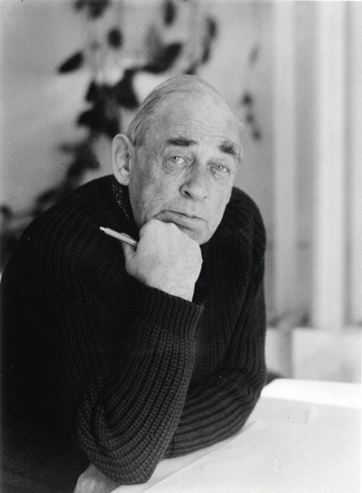
Alvar Aalto was born Hugo Alvar Henrik Aalto in Finland on February 3, 1898. He was a renowned architect but did create sculptures, paintings and pieces of furniture (Alvar Aalto: Biography & Quotes, 2017). Aalto’s first wife, Aino Maria Mandelin, was a Finnish architect and a pioneer of Scandinavian design. Aino’s interest in Scandinavian design, which focuses on simplicity, minimalism and functionality, had a great influence on Alvars’ designs. Aalto believed that architects ''should work for simple, good, undecorated things” (1957). This mindset is reflected in his furniture designs and gave inspiration to Aalto setting up his own company called Artek. The name was created as a desire to combine art and technology with the founders focusing on natural materials, a humane approach and long-term durability. His style is considered as Scandinavian due to their simple and practical designs.
Figure 1; Alvar Aalto; Wikipedia.org

Design and Influence
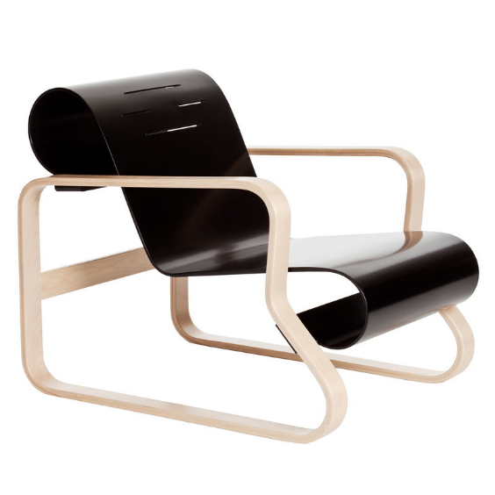
Aalto ordered many pieces of metal furniture for his home in 1927. He noticed the tubular steel framework incorporated in the pieces had its limitations and decided to create an alternative. From this he became fascinated with laminating and bending plywood and began experimenting these methods. It was through this interest that he created the Paimio chair. This chair was created for a hospital. It was a low seated lounge chair which was designed to make breathing easier for tuberculosis patients (Weston, R, 1997). This pioneering design was different to Aalto’s previous chairs that had been supported by four separate legs as the Paimio chair consisted of two frames acting as legs. These legs supported an unframed L-shaped seat, bent out of a single sheet of thin plywood, curved at the top and bottom into bold cylinders (See Fig. 2). This design of bending wood, solved an age old problem of joining vertical legs to horizontal seats. Due to Aaltos developments, furniture made from plywood and bentwood became very popular in Europe during the 1940s and became to symbolise the modern way of life at that time (Isohauta, T.,2013). His designs can still be seen in many products on the market today with examples of this style evident in many of Ikeas products.
Fig.2; Paimio Chair; Finnishdesignshop.com
The Tank/400 Chair
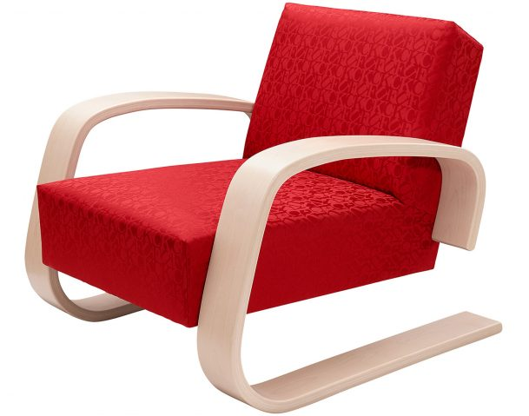
The Paimio chair paved the way for unorthodox chair design and inspired Aalto to create many more unique pieces including the Model 400 or ‘Tank’ chair (See Fig. 3). Similiar to the Paimio, the Tank chair does not consist of 4 separate legs supporting the seating of the chair, instead, features a curved birch plywood cantilever frame which curves underneath the seat. A cantilever chair is created when the seating and framework are not supported by the typical arrangement of four legs. Instead, the seating is held erect and elevated by one or two legs that are fixed to one end of the chairs seat. The legs are bent in an L shape in order to act as a supporting base (van den Elshout, Guido J, 2007). This chair provides additional comfort from the Paimio with an upholstered and padded seat.
Figure 3; Model 400/Tank Chair; dezeen.com
Material
Many designers of this period were using tubular steel to create curved elements for elaborate designs on furniture. However, Aalto decided wood was a better alternative as it was a more comfortable and warmer material while still offering a surface which can be cleaned easily. Beech was the more preferable wood of choice used during the manufacture of the original Tank chair. However, beech wood does not have the great strength or moisture resistance which is required for furniture making. Today, Aalto furniture is strongly associated with Finnish-grown birch (See Fig.4) due to its abundance in Finland, where the Artek factory is located. 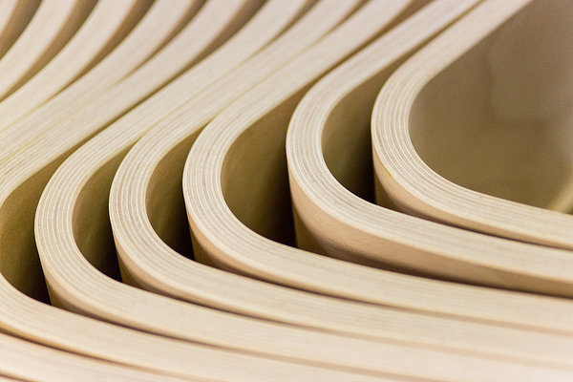Figure 4; Birch laminates forming a bend
Its flexibility and resistance to shock make it an ideal material for items like the Tank chair, which is a cantilever chair. While Finnish birch’ characteristics are suited to furniture making, it is not as well suited to conventional bending techniques involving steaming. An example of this downfall was seen in the Thonet-Mundus furniture competition in 1929. Aalto had six furniture entries designed and there was a series of complaints regarding the beech dowels used as a jointing technique. Despite this, the use of birch still made sense economically for Aalto while offering a pure and exotic appearance.
Manufacturing Techniques
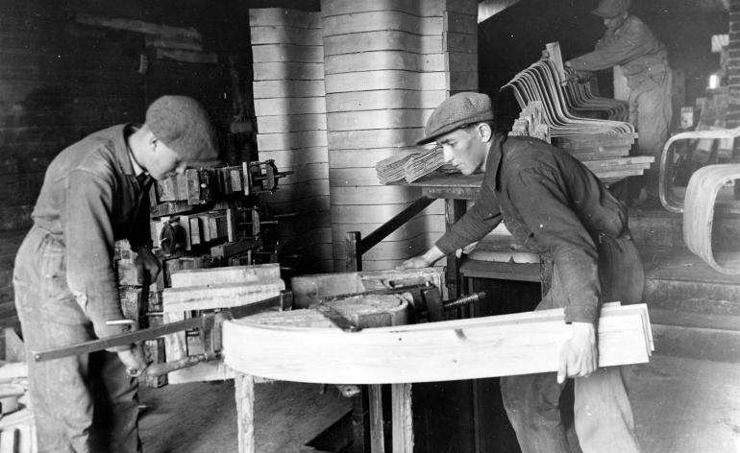
To create the sides/legs of the chair, Aalto used laminated wood, formed with the grain of each layer running parallel with one another is used. This parallel grain direction maintains the flexability of the piece despit the number of laminates used to create thicker pieces. Laminated wood is when laminates or layers of wood are sandwiched together to make thicker or longer elements. The layers can run with the grain in paralell with one another or across one another which is also known as cross-grained. Laminates can be cross grained to make them more rigid. Curves in laminates are created by applying glue to and moulding the laminates into shape. A mould and clamps can be used to hold the laminates in place while the glue dries. Large wooden blocks can be used to form a template on a large board forming the shape of the chairs’ legs/sides (See Figure 5).
Figure 5; Artek workers using a mould to bend laminates; www.walpaper.com
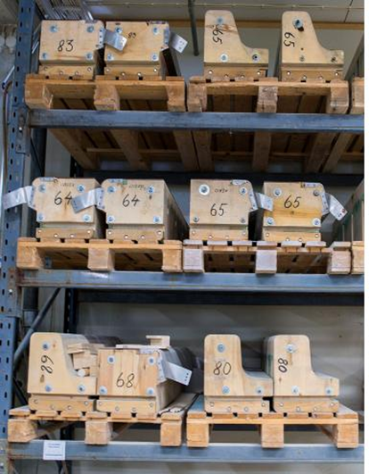
Aalto also used bentwood as an alternative to forming or moulding laminates. For creating bentwood, solid wood is used. Aalto developed a combination of cutting and steaming local Birch wood in order for it to become malleable. Firstly the timber is soaked in water. Slots are then sawn, a few millimetres apart, along the grain in one end of the timber. This weakens the timber at this point allowing it to be shaped or moulded. The depth of the cut depends on the bend that is needed. The deeper the cut is, the more the timber is likely to bend. Thin strips of veneers arewere then placed within these slots and glued in place to stablise the bend and hold it in position. Today, Aaltos furniture manufacturing is likely to involve the use of machines for the process of creating curves. The use of male and female moulds within a hydraulic press reduces the labour and risk of movement involved when forming curved pieces. Male and female moulds are typically used for production of larger quantities of laminated or formed-plywood parts. Matching male and female formers can be cut from solid wood but it is preferred to use built up man-made boards due to the reduced risk of movement of the board. The former must be designed to use the minimum amount of material while applying even pressure over all the faces of the lamination (Stevens and Turner, 2008).
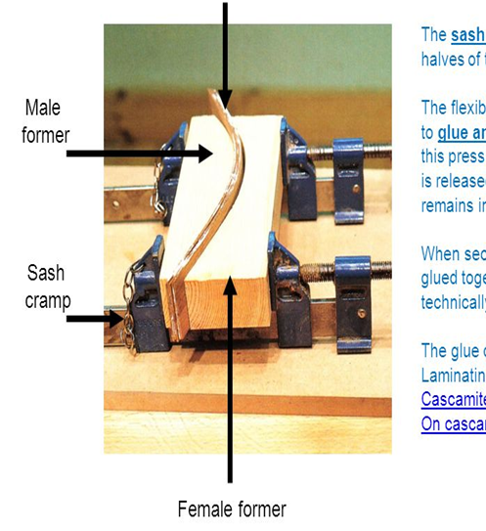
Figure 6; Male and Female formers in Aaltos factory (left); wallpaper.com; and a clamp using a male and female former (Right); slideplayer.com
To manufacture the curves on the Tank 400 chair for this project, a simple male former will be used (See Figure 6; right) as there is only two pieces, the two sides/legs, that need to be curved. Male formers are simple to make and are particularly suited for making large components like the sides of a chair. This is done by figuring out the shape and dimensions by making a full-size drawing. then mark it out on the face of the block and cut it to shape on a band saw. The clamps should be fixed perpendicular to the form and evenly spaced to ensure even pressure is applied. The number of clamps depends on the severity of the bends.
Adhesives
For the original Tank chair, Casein glue was the glue of choice as it has a greasy effect between the layers and allows them to slide between eachother when bent under pressure. Casein glue is composed of casein curd which is got from skim milk or buttermilk by letting the milk sour naturally or by adding acid to it. Casein glues are known for their good resistance to moisture but they can stain wood. The needs for milk in food production has also been prioritised to that of creating adhesives, resulting in an increase in price of casein glues (G, Wengert, 1998). In regards to glues available today, polyurethane offers many of the same properties as Casein glue, giving good resistance to impact and offering good shear strength. Shellac was a popular finish in 1936, when the original Tank chair was constructed but synthetic lacquers were becoming more popular during this period (Jones, D, 2014). Shellac is not a partically hard-wearing finish. Today, pieces like chairs and tables are often finished in a varnish. Varnishes can offer a variety of appearances such as matte, satin or gloss. The reason varnishes is popular for use on furniture is its clear tough finish which offers protection to stains, offers an easy to clean surface and enhances durability (Stevens and Turner, 2008).
Conclusion
Its clear from this report, that the model 400 chair is an icon of furniture design. Its design and engineering made it one of the pioneering pieces of furniture of its era. There is a clear link which shows how this chair became inspired by the paimio chair designed by Aalto previously and the materials used to construct the artefact itself were carefully choosen based on their characteristics. A reproduction of this chair can incorporate alternative techniques, materials, finishes and adhesives to the original in order to develop the design or manufacturing. These developments may be within durability, ease of manufacture, appearance, etc., by evolving the piece, without diminishing the original, for it to still be considered a ‘Modern’ piece of furniture 80 years from now.

Reference Page
- Alvar Aalto: Biography & Quotes. (2017, May 31). Retrieved from https://study.com/academy/lesson/alvar-aalto-biography-quotes.html.
- Jari Jetsonen; Jetsonen Sirkkaliisa (20 March 2008). Finnish Summer Houses. Princeton Architectural Press. pp. 48–. ISBN 978-1-56898-752-1.
- Richard Weston, Alvar Aalto, Phaidon, 1997
- uhani Pallasmaa, Alvar Aalto: Through the Eyes of Shigeru Ban, Black Dog Publishing, 2007
- Mihoko Ando, Patrick H Fleming, A Study of Alvar Aalto’s Wood Reliefs for Furniture and Architectural Design, Journal of Design History, Volume 32, Issue 2, May 2019, Pages 146–169, https://doi-org.tudublin.idm.oclc.org/10.1093/jdh/epy042
- van den Elshout, Guido J. "The Cantilever Chair: By Mart Stam, by Ludwig Mies van der Rohe or by Marcel Breuer?". Chair Blog.
- Jones, D., 2014. French Polishing. Gmc Publications Ltd, p.94.
- Isohauta, T. (2013). The diversity of timber in alvar aalto's architecture: Forests, shelter and safety. Arq : Architectural Research Quarterly, 17(3-4), 269-280. doi:http://dx.doi.org.tudublin.idm.oclc.org/10.1017/S1359135514000086
- G, Wengert, 1998. Types and Properties of Woodworking Adhesives The Wood Doctor's dissertation on wood glues
- Stevens, W. and Turner, N., 2008. Wood Bending Handbook. East Petersburg, PA: Fox Chapel Pub.

